CSA1505 - CLOUD COMPUTING AND BIG DATA ANALYTICS
Experiment-8

7. Create a simple cloud web application for student counselling system using any Cloud Service Provider to demonstrate SaaS with the fields of student name, age, address, phone, subjects studied, Year of passing, percentage of marks, domain interest, etc.
AIM:
To develop a simple Student Counselling System using Zoho Creator (Cloud Service Provider) to demonstrate the Software as a Service (SaaS) model. The application stores student personal and academic details, identifies their domain of interest, and automatically updates the counselling status based on their academic performance.
PROCEDURE:
- Log in to Zoho Creator.
- Create a new application named Student Counselling System.
- Design a form with fields such as student name, age, address, phone number, subjects studied, year of passing, percentage of marks, domain interest, counselling date, and counselling status.
- Configure the required field types and drop-down values.
- Create a workflow to automatically record the counselling date and assign the counselling status based on the student's percentage.
- Save and publish the application.
- Enter sample student details and verify that the application stores the information and updates the counselling status automatically.
INPUT:
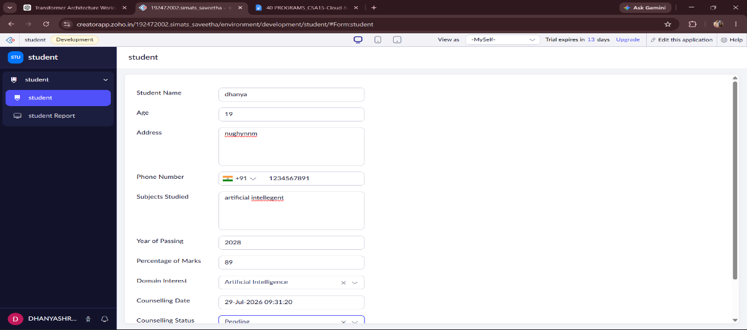

OUTPUT:
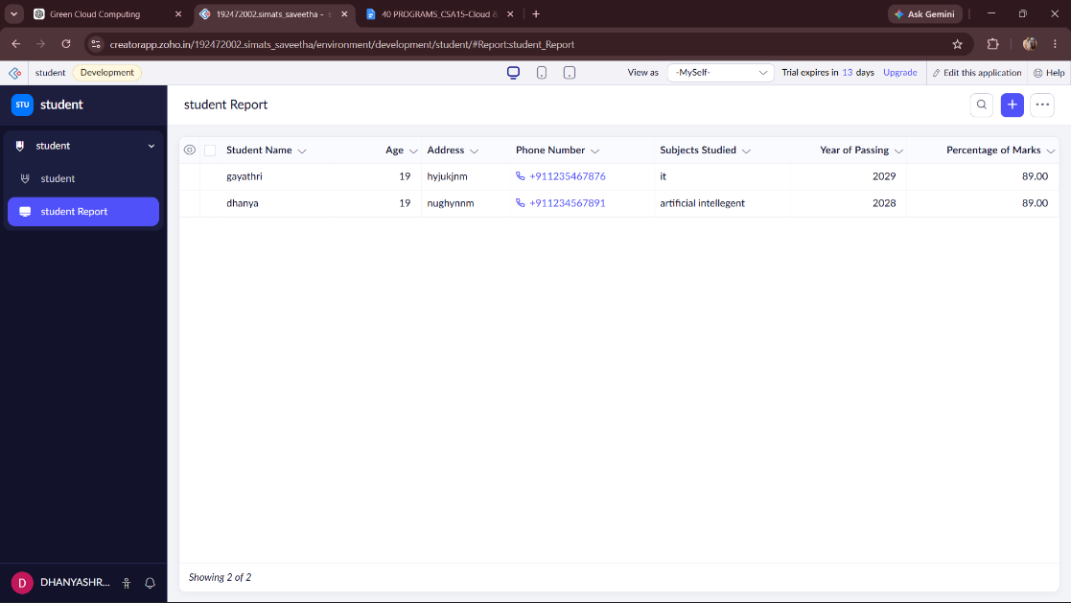
DESIGN:
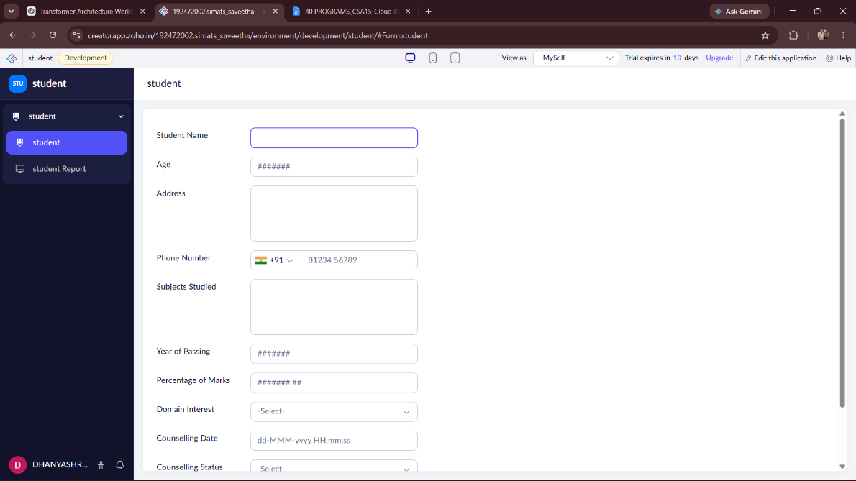

WORKFLOW:
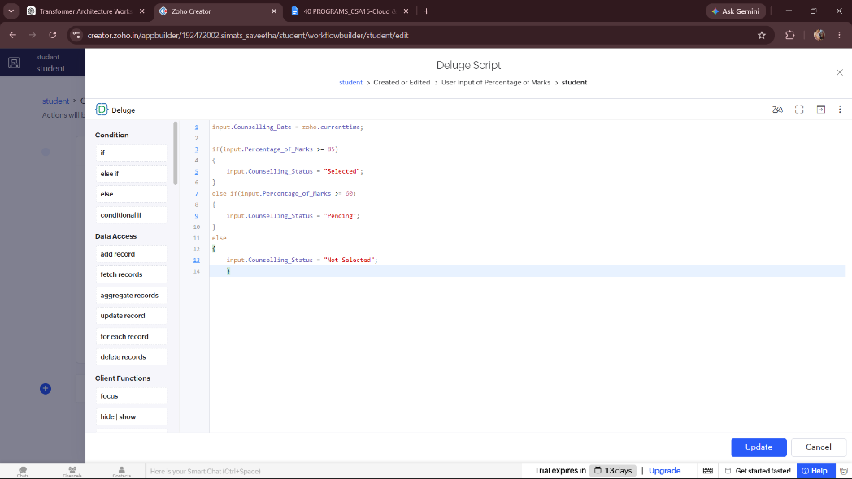
RESULT:
A cloud-based Student Counselling System was successfully developed using Zoho Creator. The application stores student personal and academic details, records their domain interests, automatically updates the counselling date and counselling status, and demonstrates the Software as a Service (SaaS) model using a cloud platform.

